This dense mass increases mass by acceleration due to the reduction of space. These “balls” of clumped “dead photon particles push closer and closer towards eac other and pressure makes all kinds of bends, bulges, until dust and the bends and bulges = more surface area for smaller and smaller photon particles to stick to and fill 🡪 blocks more light energy [ie: clogged artery]

\*\*Bad things happen as symbols to allow rational thinking to remove the blockages somehow or create new paths for the light to get across.

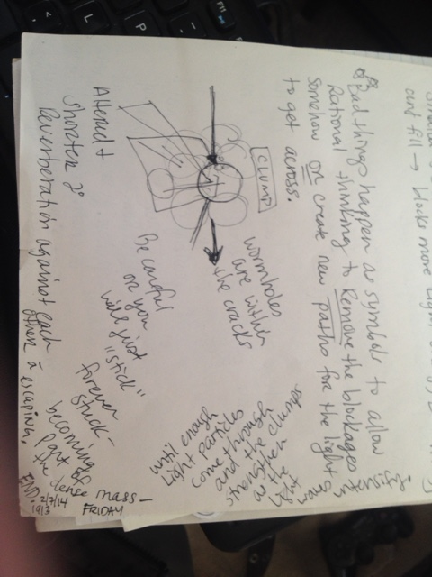

4) This is when the light dissipates (the recession of time due to the end of a lightwave’s wave length)

?What happens there? The space between the end of a wavelength and nothing before it recedes.

The light and photons still refract and the wave weakens (because some photons are destroyed upon impact and the “light” weakens due to less particles being refracted.

There is “light” everywhere, but it is weaker and weaker and weaker and the space between is always relative. (Sacred Geometry)

Maybe these particles clump up – like the bubble game and eventually form mass, but no light – except possibly so dim and not of it’s own because it’s just a reflection of a passing photon. A small amount of energy enters and dissipates as the smaller waves clump faster due to the decreasing space for the photons to stop. This happens exponentially and it grows denser.